**Bank Marketing Dataset Analysis Report**

**1. Overview**

The primary goal is to build a predictive model to classify whether a customer will subscribe to a term deposit (y). This involves identifying important features, optimizing model performance, and ensuring interpretability.

**2. Data and Model**

**Data**

* The dataset contains information collected from a marketing campaign by a Portuguese bank. It includes customer details (e.g., age, job, marital status) and campaign-specific attributes (e.g., contact method, duration). The target variable is binary: yes (subscribed) or no (not subscribed).

1. **age** (numeric)
2. **job** : type of job (categorical: "admin.","unknown","unemployed","management","housemaid","entrepreneur","student","blue-collar","self-employed","retired","technician","services")
3. **marital** : marital status (categorical: "married","divorced","single"; note: "divorced" means divorced or widowed)
4. **education** (categorical: "unknown","secondary","primary","tertiary"
5. **default**: has credit in default? (binary: "yes","no")
6. **balance**: average yearly balance, in euros (numeric)
7. **housing**: has housing loan? (binary: "yes","no")
8. **loan**: has personal loan? (binary: "yes","no")

*related with the last contact of the current campaign:*

1. **contact**: contact communication type (categorical: "unknown","telephone","cellular")
2. **day**: last contact day of the month (numeric)
3. **month**: last contact month of year (categorical: "jan", "feb", "mar", ..., "nov", "dec")
4. **duration**: last contact duration, in seconds (numeric)
5. \

*other attributes:*

1. **campaign**: number of contacts performed during this campaign and for this client (numeric, includes last contact)
2. **pdays**: number of days that passed by after the client was last contacted from a previous campaign (numeric, -1 means client was not previously contacted)
3. **previous**: number of contacts performed before this campaign and for this client (numeric)
4. **poutcome**: outcome of the previous marketing campaign (categorical: "unknown","other","failure","success")

*Output variable (desired target):*

1. **y** : has the client subscribed a term deposit? (binary: "yes","no").

* After cleaning, the data was split into training and testing sets (80-20 split).

**Approach**

1. **Data Cleaning:**
   * Checked for missing values and there were no missing values.
   * 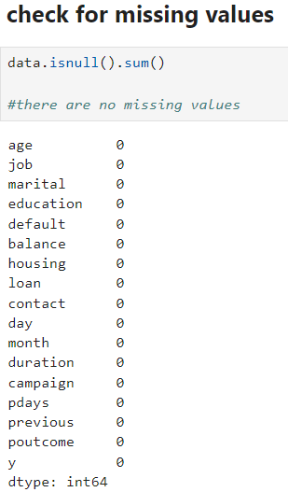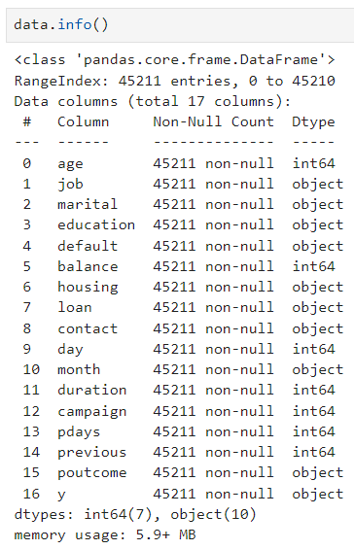Verified data types, there are no columns where type conversions is necessary.
   * 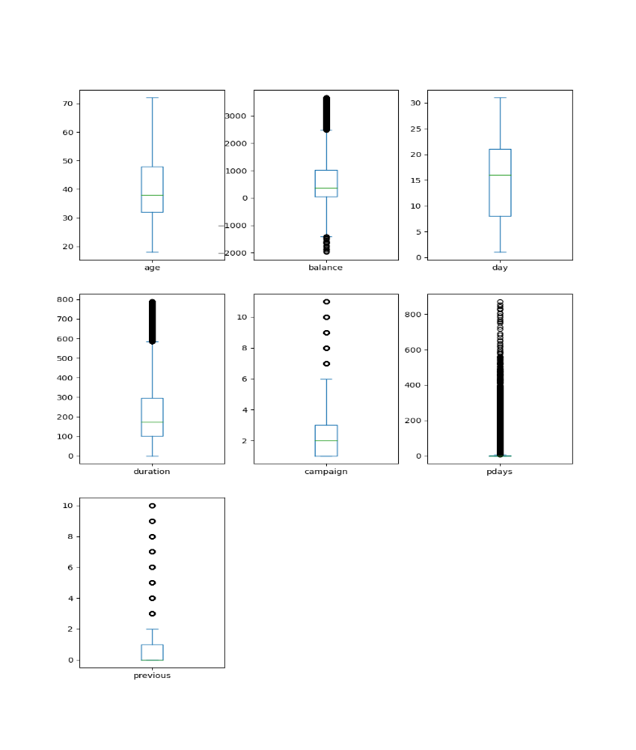Identified and Handled Outliers using boxplot and IQR method respectively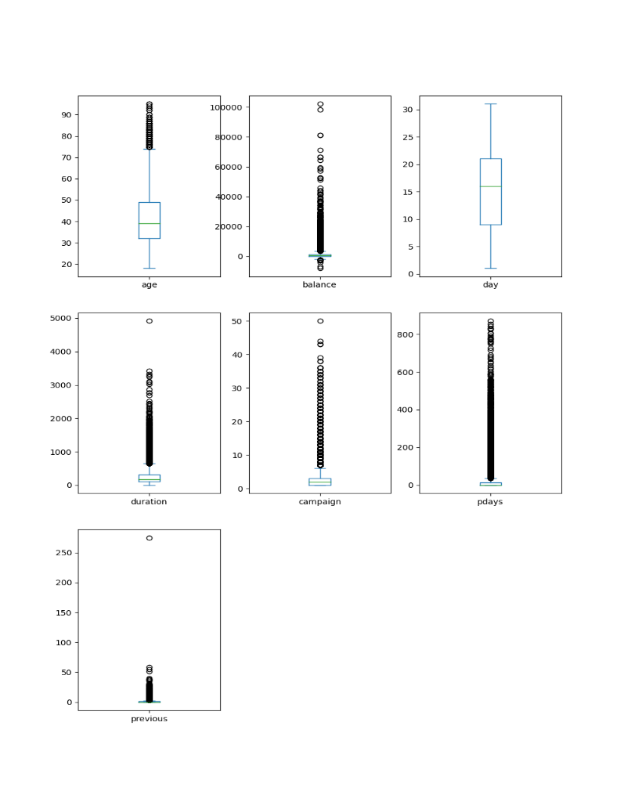.
2. **Exploratory Data Analysis (EDA):**
   * Analysed distributions of numerical variables (e.g., age, balance).
   * 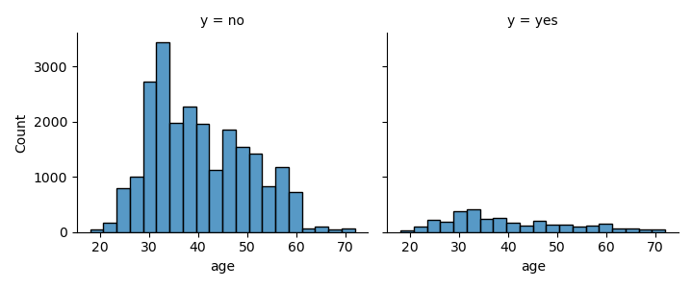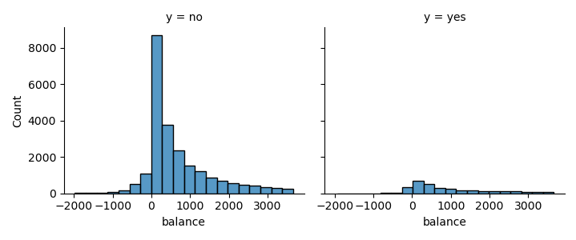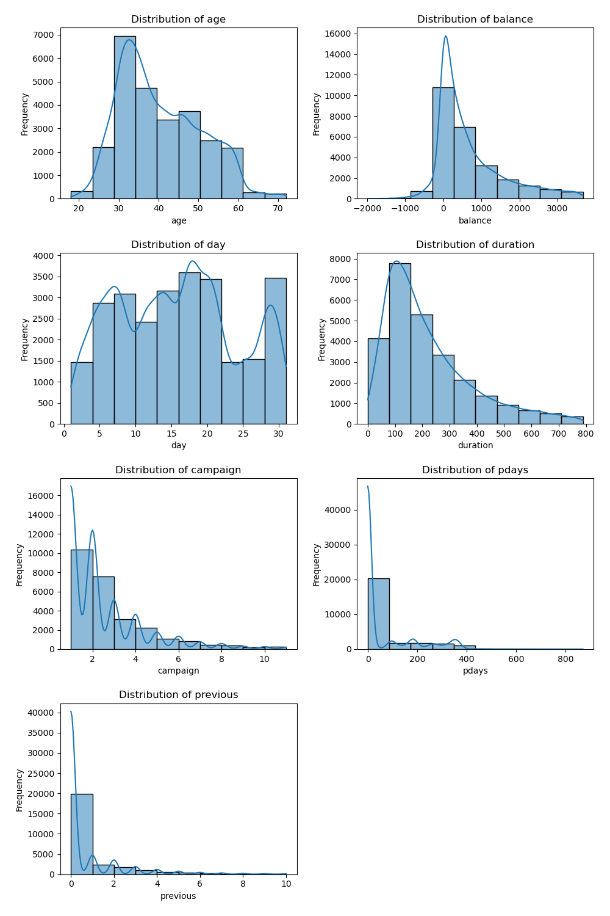 Where age, balance, duration, campaign, pdays, previous all are right skewed

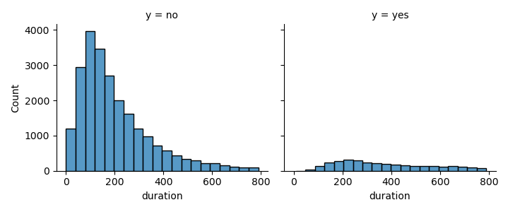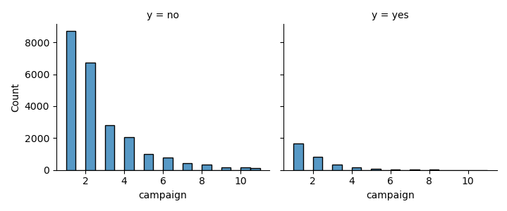

* 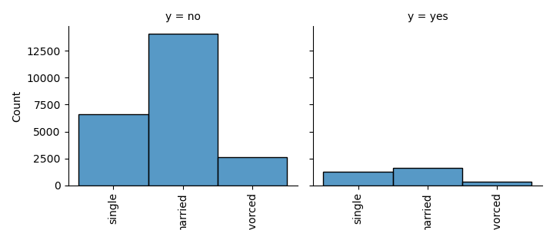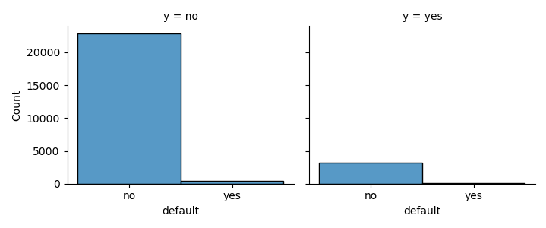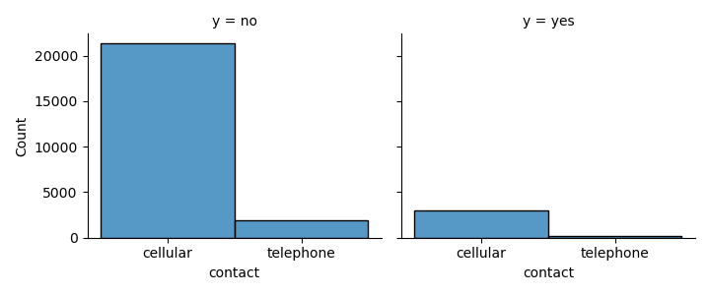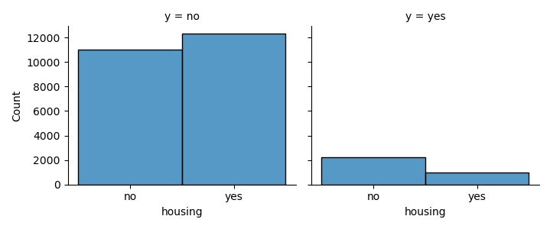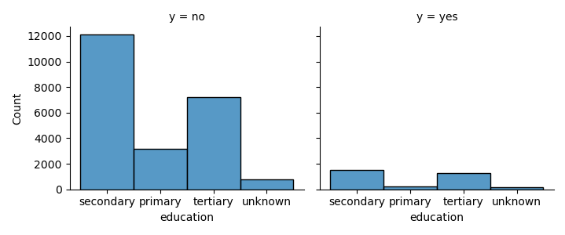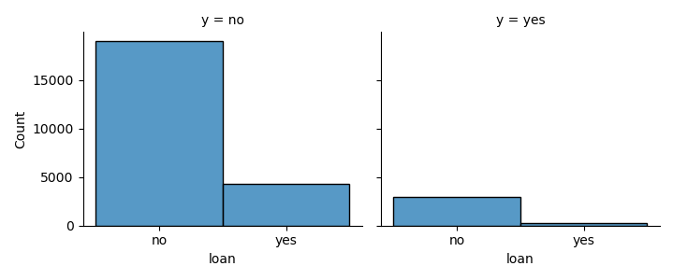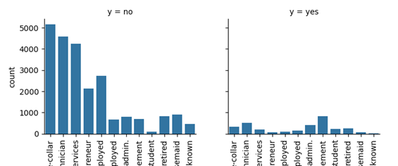**Age :** Younger demographic (age less than 40-50) have a higher chance to subscribe to a term deposit.
* **Balance :** Customers with a balance between 0 and 1000 are more likely to use a term deposit.
* **Campaign :** During the campaign to the customers with contact of 2 to 4 times have took subscription.
* **Duration :** The duration from 300 to 500 (sec) are more likely to subscribe to a term deposit by the customer.
* **Job :** Most of the customer who took term deposit are working in management, technician, administration and blue-collar.
* **Marital :** Married customers are interested in term deposite, followed by singles.
* **Education :** Majority customers contacted were secondary and tertiary educated.
* **Default :** Most of the customers who took subscription are not defaulter so this column can be dropped.
* **House Loan :** Majority of customers who took term deposit don't have house loan.
* **Loan(Personal loan) :** Majority customers who took subscription do not have personal loan.
* **Contact :** Majority customers were contacted via cellular.
* Examined relationships between numerical variables (e.g., job, marital status) and the target variable.

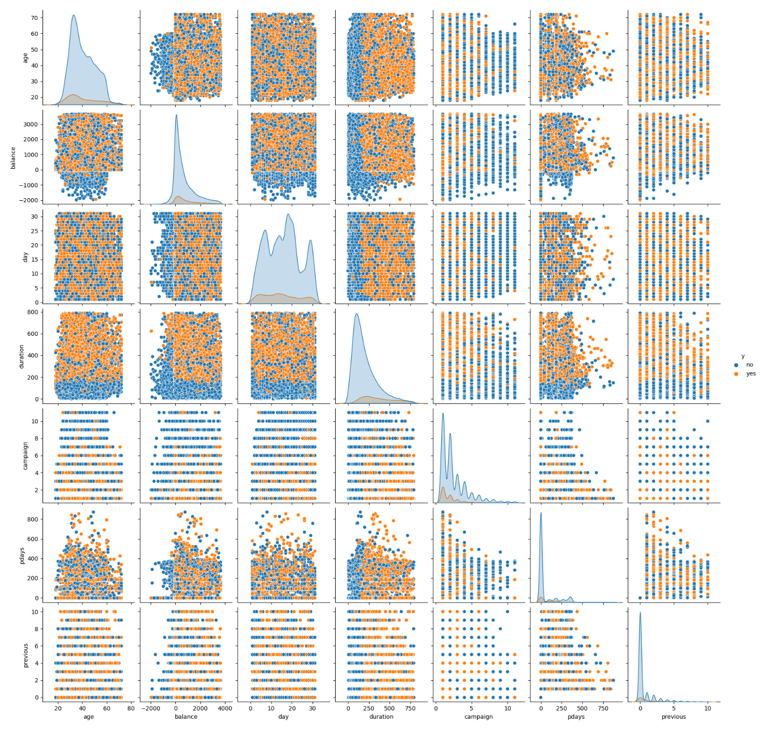

* **Age vs Balance** : There is non-linear relationship between age and balance. Subscribers are more likely to have positive balance regardless of age. among subscribers, middle aged customers (between 40 to 50 years) tend to have higher balances.
* **Age Vs Duration** : Relationship is non linear. Subscriptions are strongly concentrated in cases with longer durations of calls (>300 to <500) seconds across all age groups. middle aged customers (>40 to <50) tend to have longer calls leading to subscriptions.
* **Balance Vs Duration** : Relationship is non-linear. Subscriptions occur when balances are positive (>0) and durations are long (>300 seconds). Customers with high balances (>1000) are more likely to subscribe if the call duration is long.
* **Age Vs Campaign** : Non-linear negative relationship. Subscriptions are common in the first few campaigns(1-4), regardless of age. Middle aged customers (40 - 50 years) have higher subscription rates at lower campaign counts.
* **Balance Vs Campaign** : Relationship is non-linear. Positive balances and lower campaign counts(1-4) leads to subscriptions. Few subscriptions occur at higher campaign counts(>4) even for customers with high balances.

1. **Feature Engineering:**
   * 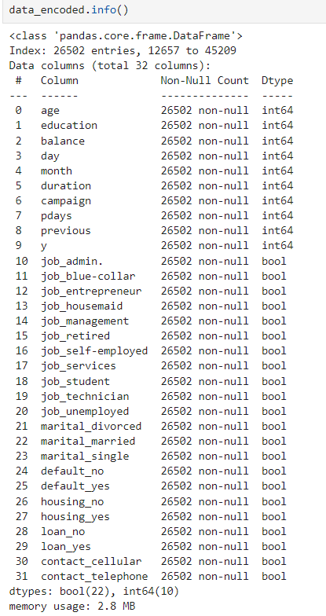Encoded categorical variables using label encoding and one-hot encoding.
2. **Data Visualization:**
   * Used bar charts, histograms, and boxplots to identify trends.
   * Created correlation pair plot to detect multicollinearity among numerical features.
3. **Model Selection:**
   * Logistic Regression (baseline model).
   * Tree-based methods (Random Forest, Decision Tree, Extreme Gradient Boosting).
   * Evaluated models using metrics such as Accuracy, Classification Report, Confusion Matrix, Roc Curve, AUC Score .
4. **Model Evaluation:**
   * Plotted ROC curves and calculated AUC to compare models.
   * The AUC (Area Under the ROC Curve) score summarizes the model’s performance across all thresholds. A higher AUC indicates a better-performing model.
   * Analysed feature importance for interpretability.

**3. Results**

**Model Performance:**

* **Logistic Regression:** Baseline accuracy of 80.30%
* **Random Forest:** Accuracy of 93.93%, with the highest AUC (0.9867).
* **Decision Tree:** Accuracy of 90.50%, with lower recall and precision compared to Random Forest.
* **Extreme Gradient Boosting:** Accuracy of 93.89%, but with slightly lower recall compared to Random Forest.

**Feature Importance:**

* The most important features influencing the prediction include **duration**, **age**, **balance**, and **campaign**.
* Partial dependence plots indicate that longer call durations and higher balances are positively associated with subscription.
* Categorical features like job and marital status also contributed significantly.

**Visual Insights:**

* 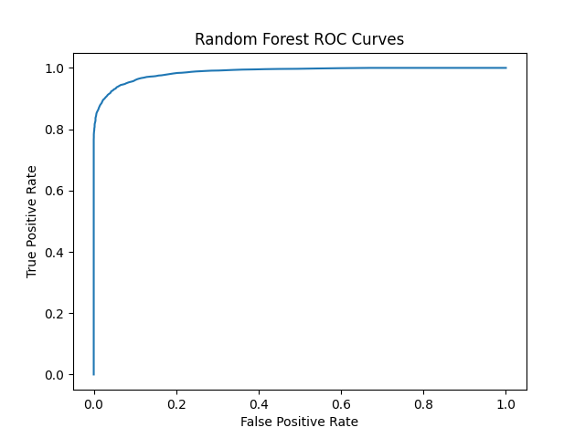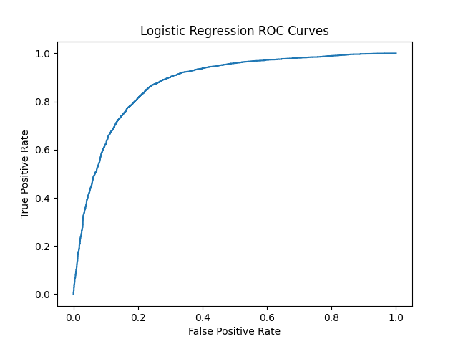**Figure 1:** ROC curves for all models.

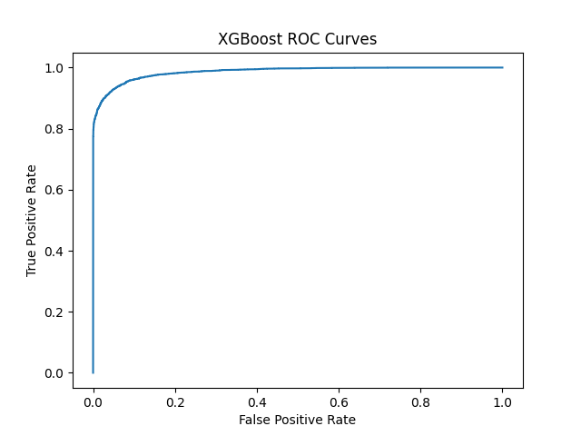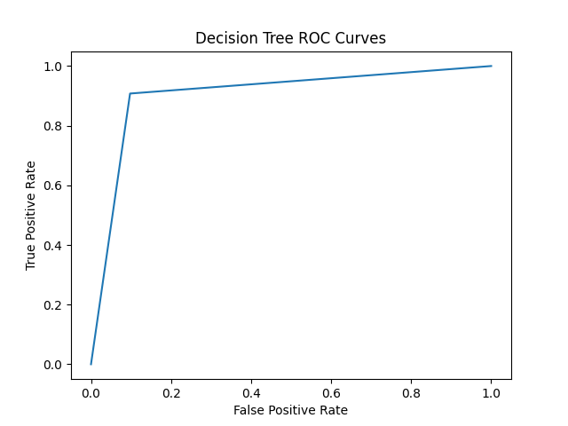

* **Figure 2:** Feature importance plot from the Random Forest model.
* Feature importance plot is a great way to understand which features have the most influence on our model's predictions.

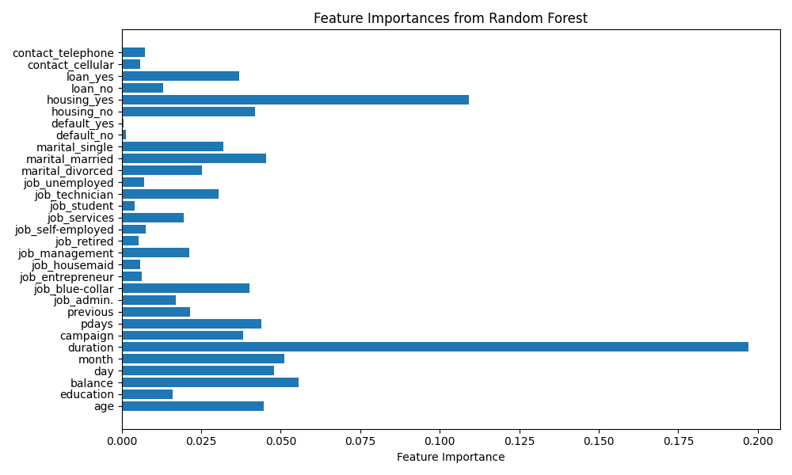(Important Features : duration, housing loan, balance, marital married, age, job blue collar )

**4. Conclusion**

* Random Forest outperformed other models in predictive accuracy and interpretability.
* Focus marketing efforts on clients with longer call durations and higher balances.
* Tailor strategies based on important features to improve campaign effectiveness.
* Continuously monitor and update the model to ensure its accuracy and relevance with new data.